**Configure Citrix Cloud**

***Requires Goliath Performance Monitor v11.9 or later.***

**Prerequisites**

To enable Citrix Cloud monitoring, you'll need the following:

* Citrix Customer ID
* Citrix Client ID
* Citrix Secret Key
* Citrix Profile Manager must be enabled on the VDA for Logon Duration metrics
* PowerShell 3.0 or newer required on the VDA
* Full Microsoft SQL suggested for full implementations of Goliath Performance Monitor
* Support for real-time process metrics can be resource intensive requiring us to determine viability that we would test in the implementation.
* An updated Goliath license key

You can generate an obtain the required Citrix credentials and details from your Citrix Cloud instance in the Identity and Access Management area. The following article describes the required steps.

[Citrix Docs: Creating API Client](https://developer.cloud.com/explore-more-apis-and-sdk/cloud-services-platform/citrix-cloud-api-overview/docs/get-started-with-citrix-cloud-apis)

**Enable Citrix Cloud Monitoring**

1. Log in to your Goliath server and go to the **Configure > Inventory**page.
2. Locate your Goliath server in the inventory list, select it, and click **Edit.**
3. In the dialog that opens, click **Enable Citrix Cloud**.
4. Enter the Citrix Cloud credentials and click **Save.**
   1. 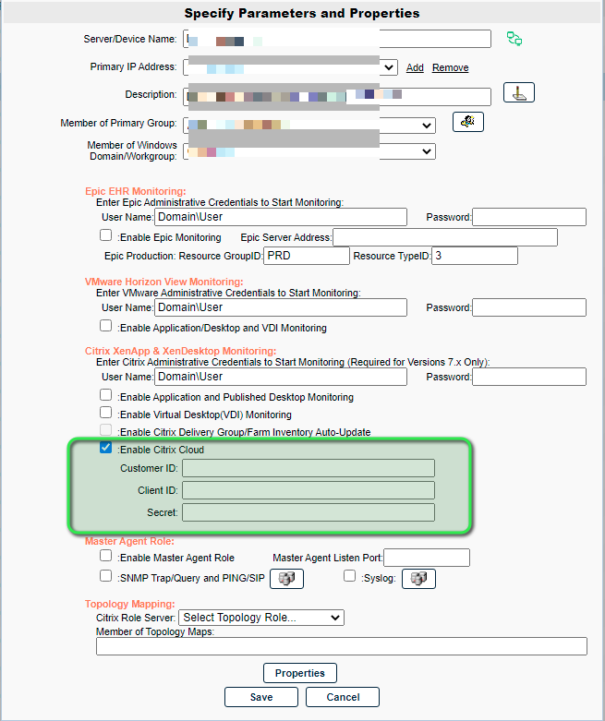After a few minutes, you will begin to see Citrix Cloud session data displayed in the **Views - Citrix Virtual Apps and Desktops** dialog.
5. Next install Goliath agents to the VDA devices within your environment. See the post configuration section at the bottom of this article for additional details.  
   Note: The Goliath agents are required to collect and display additional Citrix session metrics.

**Enable Citrix Cloud Connector Monitoring**

**NOTE:** This requires a Citrix Cloud module installed to GPM that allows you to import and install Citrix Cloud Connector rules. To obtain the Citrix Cloud module, contact your Goliath Implementation engineer.

1. Go to the **Configure** - **Inventory** page.
2. Next, add your Citrix Cloud Connector Devices:
   * Click **New** at the top of the page and fill in the appropria
   * te information (server name, ip address, domain, etc) then click **Save**. Repeat for the additional Citrix Cloud Connector Devices.  
     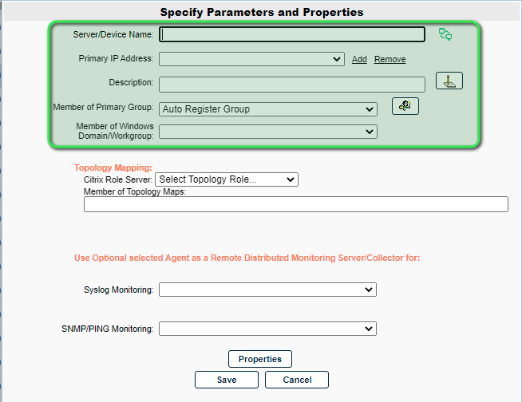
3. To enable Citrix Cloud Connector monitoring, deploy an agent to the Citrix Cloud Connector devices. This can be done by clicking **Manage Agents** at the bottom of the page.
4. When the **Manage Agent** dialog opens, select the Cloud Connector Device(s) that you would like to deploy an agent to.
5. The first time an agent is deployed to a server, you must choose the **Deployment Settings** button and enter one-time local administrator credentials in order to copy over and run the install files. *These credentials are not saved anywhere in the database*. Once an agent connection has been establish this step is no longer needed.
   * 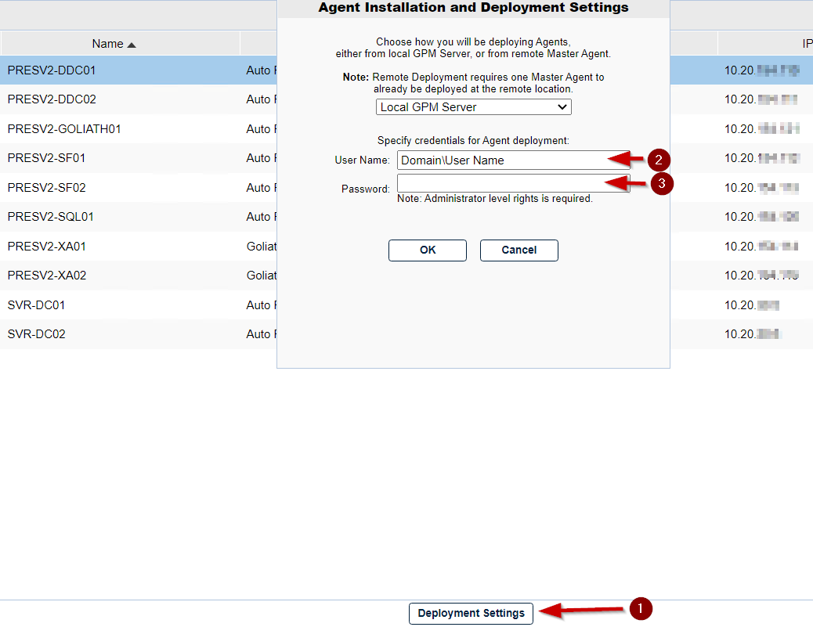
6. Click the **Install/Update Agents** button at the bottom of the dialog to begin the agent installation. You will see a prompt warning you to enter credentials if this is the 1st agent deployment, click **OK** to bypass and begin the agent installation
7. Depending on the number of Agents that are being installed, the process may take a few minutes to complete (do not refresh the page). You will see green checkboxes appear as the agent installation succeeds
8. Once all agents have been installed, you will receive a prompt that the installation is complete. Click **Close** at the bottom of the dialog to return to the Inventory page.
9. Once on the Inventory page, confirm the agents are connected by looking at the **Agt** column and identifying a green box. This could process could take a 1-3 minutes and you will need to refresh the page.
   * 
   * Note, if you do not see an icon in the **Agt** column after 5 minutes, confirm that the Goliath Server is accepting inbound TCP communication on all firewall levels (Domain, public, private) and that the server where the agent is installed is allowing outbound TCP communication for all firewall levels.
10. Once the agent for the Cloud Connector Devices are connected you'll need to configure monitoring for them. Navigate to **Configure - Monitoring Rules page**
11. Click the menu icon and chose the submenu option for **Import/Export Rules.**
12. In the dialog that opens, select **Import Monitoring Rules**and click **OK.  
    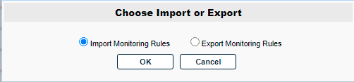**
13. In the next dialog, select **Citrix Cloud**from the list and click **OK.**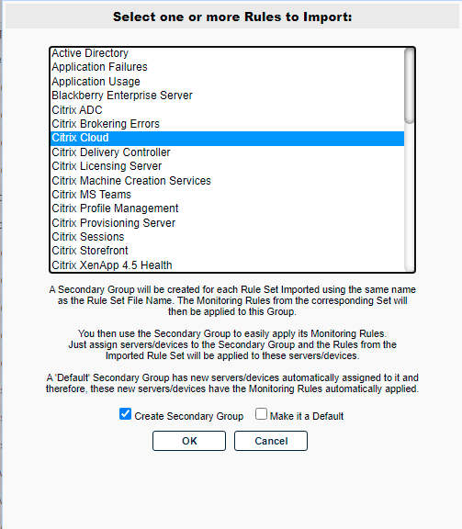
14. The new rules are imported to the Monitoring Rules table. Refresh the page to view the new rules.
15. Next, add your Citrix Cloud Connector devices to be monitored. Navigate to the **Configure - Groups** page, select the line item for **Citrix Cloud** and click **Edit.**
16. In the dialog that opens, select the button in the middle of the pane for **Servers/Devices.**
17. Scroll through the list of servers and select your Cloud Connector Device(s) then click **Apply.**
18. Click **Save.**

**Post Configuration: What’s Next?**

Now that Citrix Cloud monitoring has been enabled in Goliath Performance Monitor, to start collecting user session data and alerting on faults taking place you’ll need to **deploy an agent onto your session hosts and/or VDI’s**. Please see additional documentation below.

**Please note:** If you are using **PVS or MCS** to deploy your Citrix environment, the agent will need to be installed into the Gold and or Master Image(s).

* [Agent Installation/Update via the Goliath Console](https://support.goliathtechnologies.com/hc/en-us/articles/360025093394)
* [Agent Installation/Update for Gold Images, Master Images, & Templates](https://support.goliathtechnologies.com/hc/en-us/articles/360025009874)
* [Silent Agent Installation/Update](https://support.goliathtechnologies.com/hc/en-us/articles/360025012374)
* [Agent Installation/Update via Installer](https://support.goliathtechnologies.com/hc/en-us/articles/360025959993)
* [Agent Installation/Update via Command Line](https://support.goliathtechnologies.com/hc/en-us/articles/360025008894)
* [Facebook](https://www.facebook.com/share.php?title=Configure+Citrix+Cloud&u=https%3A%2F%2Fsupport.goliathtechnologies.com%2Fhc%2Fen-us%2Farticles%2F360063881973-Configure-Citrix-Cloud)
* [Twitter](https://twitter.com/share?lang=en&text=Configure+Citrix+Cloud&url=https%3A%2F%2Fsupport.goliathtechnologies.com%2Fhc%2Fen-us%2Farticles%2F360063881973-Configure-Citrix-Cloud)
* [LinkedIn](https://www.linkedin.com/shareArticle?mini=true&source=Goliath+Technologies&title=Configure+Citrix+Cloud&url=https%3A%2F%2Fsupport.goliathtechnologies.com%2Fhc%2Fen-us%2Farticles%2F360063881973-Configure-Citrix-Cloud)

Was this article helpful?